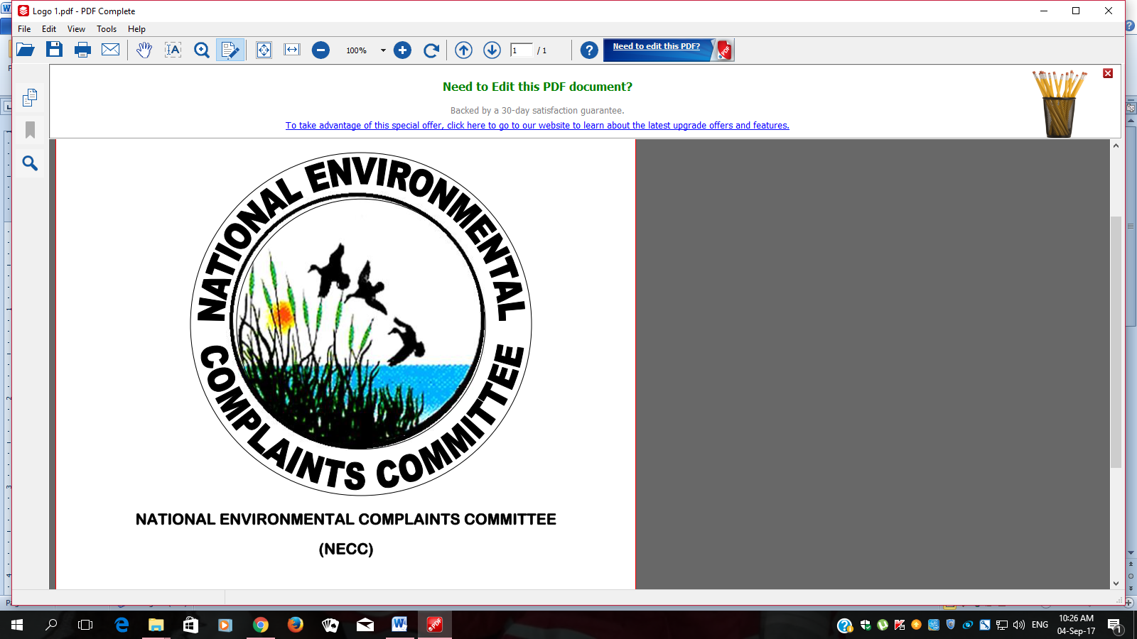

NATIONAL ENVIRONMENTAL COMPLAINTS COMMITTEE

A REPORT ON STATUS OF SOLID WASTE MANAGEMENT IN KENYA

APRIL 2021

TABLE OF CONTENTS
TABLE OF CONTENTS 2
LIST OF TABLES 2
LIST OF FIGURES 2
EXECUTIVE SUMMARY 3
1.1 Waste and its sources 4
1.2 METHODOLOGY 4
1.3 Waste as an Economic Business 5
1.4 Waste as Source of Energy 5
2 NEED FOR PROPER SOLID WASTE MANAGEMENT IN KENYA 7
3 SITUATIONAL ANALYSIS 9
3.1 Some of the solid waste management complaints investigated by NECC 9
3.1.1 General waste management in Counties 9
3.1.2 Solid Waste Management in Sugar Factories. 14
3.1.3 Asbestos 16
4 CHALLENGES IN WASTE MANAGEMENT 18
4.1 Disposal sites: Availability, siting and management. 18
4.2 Funding: 18
4.3 High poverty levels: 18
4.4 Lack of segregation 19
4.5 Limited technical competencies: 19
4.6 Slow adoption of modern technological options: 19
5 FINDINGS ON CURRENT WASTE MANAGEMENT PRACTICES AND RECCOMMENDATIONS 20
5.1 Waste Segregation 20
5.2 Collection and Transportation ∙ 20
5.3 Waste Disposal 20
5.4 RECOMMENDATIONS 21
REFERENCES 22

LIST OF TABLES
Table 1: Status of solid waste generation, collection and recovery in major towns

LIST OF FIGURES
NECC Photo 8.8.2019
Figure 1: Waste dumped along the a road next to Railway Training Institute
NECC Photo 2.08.2019
Figure 2: A truck with waste at the site
Figure 3: Open and unfenced dumping site in Nyakoe- Kisii Town
Figure 4: Nyakoe dumpsite located adjacent to a stream posing likelihood to affect environment and human health
Figure 6: Fig 1: Asbestos dumped in the open in Machakos County
Figure 7: A kiosk by the roadside made of asbestos material

EXECUTIVE SUMMARY

Waste is a resource that can be managed to achieve economic, social and environmental benefits. Addressing the waste management challenge effectively in Kenya is critical to delivering on Kenya’s constitutional right to a clean and healthy environment for all, advancing the circular economy to create green jobs and wealth from the waste sector, and advancing the nation’s sustainable development goals. Sustainable waste management is also fundamental to delivery of each of the government’s “Big Four” national priorities – the transformational agenda on housing, manufacturing, food and nutritional security and health care – and to Kenya’s leadership in the blue economy, with its focus on creating economic growth, ensuring healthy waters and building safe communities Accumulated waste deposits are an indication of societal lifestyles, waste management practices and production technology. Some societies at the peak of their development have stagnated due to inadequate management of their waste leading to proliferation of disease; environmental degradation and ultimate impact on livelihoods. Improper management of waste poses a threat to Climate Change and eventually in the achievement of sustainable development. Waste being one of the contributors of greenhouse gases, affects climate change and it is for this reason that as a country, we should develop sustainable waste management technologies and initiatives to cub this growing global challenge. Through our commitment to sustainable development, Kenya aims to balance the broader economic and social challenges of development and environmental protection. For this reason the Country subscribe to the vision of a prosperous and equitable society living in harmony with our natural resources. This is also reinforced in the constitution under the fundamental right to a clean and health environment. Sound environmental management entails use of waste reduction technologies in production, sustainable product design, resource efficiency and waste prevention, re-using products where possible; recovering value from products. Although, elimination of waste entirely may not be feasible, systematic application of modern waste management systems should be explored and implemented. To efficiently manage solid waste in Kenya, these actions are recommended. The National Government should ensure that the National Waste Management Strategy is fully implemented in all counties for effective waste management in Kenya. Additionally, the Government through the concerned agencies should wholly enforce the legal frameworks on waste management. The County Governments should ensure that waste is frequently collected at collection points so that waste does not accumulate and is not an irritant to the public. As a long term solution, County governments should venture into recycling as a way of managing the generated waste.

- INTRODUCTION

Waste and its sources

Waste is a resource that can be managed to achieve economic, social and environmental benefits. Addressing the waste management challenge effectively in Kenya is critical to delivering on Kenya’s constitutional right to a clean and healthy environment for all, advancing the circular economy to create green jobs and wealth from the waste sector, and advancing the nation’s sustainable development goals. Sustainable waste management is also fundamental to delivery of each of the government’s “Big Four” national priorities – the transformational agenda on housing, manufacturing, food and nutritional security and health care – and to Kenya’s leadership in the blue economy, with its focus on creating economic growth, ensuring healthy waters and building safe communities.

Historically, waste has been viewed solely as a problem, not as a resource and economic opportunity. The National Waste Management Policy aims to increase the value of waste over time to the Kenyan economy through industrial processing activities aimed at producing useful products or sources of energy through reusing, recycling, or composting waste.

Although waste generation is a natural part of healthy living, it becomes a threat to health and the environment if it is not properly managed. An increasing population, coupled with the dynamic needs of society, continue to increase the amount and types of waste generated, demanding appropriate responses to deal with this complex challenge. This means our perceptions and attitudes on waste management have to change.

METHODOLOGY

The preparation of this document used both primary and secondary data. Primary data involved field investigations on waste management in Counties. Data collection techniques included stakeholder consultative meetings (NEMA County Officers, Environment Officers and Public Health from County Governments). Interviews with dump site managers were also conducted to obtain in-depth information on management of waste within the sites. Additionally, photographs of waste management facilities were taken to document availability and management of the same. Field investigations were conducted in Kajiado, Nandi Bungoma, Machakos, Muranga, Kiambu, Mombasa and Kisumu.

Secondary sources used included print media, publications and County Government Reports on waste management in Kenya. The statistics used in this document are for the year 2014 hence there is need for County Governments to provide current statistics on waste management.

Waste as an Economic Business

Economies around the world have developed markets for waste, hence making waste an economic resource that has positively contributed to the livelihoods of many. According to the Journal of Waste Management, by the year 2018, revenues generated through waste management was expected to reach $60 million in the USA alone – which though impressive can be tripled if this practice is embraced by more countries. The global municipal solid waste is expected to generate about $297 Billion by the year 2020. A waste market operates just like any other market, where buyers and sellers transact in accordance to the laws of demand and supply. Waste pickers are fundamental to waste value chain. All that is needed is a structured system to ensure that there would be fair competition in this waste market. However, it would be necessary to ensure that waste management (economic) activities are devolved. In order for this waste market to be a reality, a structured system would discourage a monopoly while ensuring the licensing of qualified vendors and recyclers to trade freely.

Competition means effective, dynamic and increasingly improved waste management methods. Sellers would have networks of pickers to collect from numerous diverse locations to meet market demands. This will provide employment opportunities. Should this market operate and run effectively, the taxes collected would enable county governments to subsidize or provide free waste recovery services for specific areas, especially households who cannot afford to pay for waste collection. The waste collected would be sold in the markets and is able to be processed for reuse or for the creation of new products

Waste as Source of Energy

We are accustomed to thinking that green energy solutions come from wind, water and solar. However, waste is also a very critical resource in providing green energy solutions. Waste that is created, for example, when foods such as meat and vegetables are being processed is monumental. Many countries in the world have used this type of waste as a raw material for generating heat, electricity and methane gas. In America, industries in this sector have partnered with their government to use waste to generate energy. Global Change Biology's states that we could reduce global carbon emissions by 80% if we used garbage to make biofuels. There are many practical examples all over the world on how to turn waste into something more useful to humanity. Locally, we have trailblazers who have turned waste tyres into shoes and décor.

Kenyan artist, Cyrus Kabiru uses trash to make his masterpieces now showcased globally. There is also Alternative Energy Systems, which is a company in Kiambu that uses waste tyres and plastic into industrial oil. The solutions for waste management are within reach, we just need an attitude adjustment and the will to turn it into a resource.
(Source: https://hapakenya.com/2017/ 05/31/Kenya’s-garbage-problem-can-be tackled-by-proper-waste-management/)

NEED FOR PROPER SOLID WASTE MANAGEMENT IN KENYA

Kenya is an active party to multiple international and regional conventions that commit the Nation to address the sustainable waste management challenge. These include agreements on sustainable development and reducing waste, the control of hazardous chemicals and chemical and electronic waste, and climate change as listed below.
- The Basel Convention, ratified in 2000, which addresses the need to control the trans-boundary movement of hazardous wastes and their disposal, setting out the categorization of hazardous waste and the policies between member countries.
- The Bamako Convention, a treaty amongst African nations that prohibits the import of any hazardous (including radioactive) waste into Africa. The convention is a response to Article 11 of the Basel convention which encourages parties to enter into bilateral, multilateral and regional agreements on Hazardous Waste to help achieve the objectives of the convention.
- The Stockholm convention on persistent organic pollutants (POPs) (ratified in 2004) which seeks to protect human health and the environment from these chemicals that remain intact in the environment for long periods and have harmful impacts on human health and the environment.
- The Rotterdam Convention (ratified in 2005) which sets out the procedure for Prior Informed Consent in the International Trade of hazardous chemicals and Pesticides.
- The Montreal Protocol which provides for the phase out of the production and consumption of ozone depleting substances to reduce their abundance in the atmosphere, and thereby protect the earth’s fragile ozone Layer.
- The Nairobi Convention, a partnership between governments, civil society and the private sector, working towards a prosperous Western Indian Ocean Region with healthy rivers, coasts and oceans.
Kenya has also been a leader in promoting the reduction of Land Based Pollution to the Marine Environment globally and regionally. Kenya adopted the Sustainable Development Goals of 2015. Goal 12 requires a strong national framework for sustainable consumption and production that is integrated into national and sectoral plans, sustainable business practices and consumer behavior, together with adherence to international norms on the management of hazardous chemicals and wastes.

Provision of sustainable solid waste management services will play a major role in reducing environmental pollution (soil, water & air), improve public health, create jobs and wealth locally from waste collection, reuse and recycling, and energy generation and compost production.
Effective waste management will also reduce emissions of greenhouse gases, especially methane, from the waste sector, contributing to the achievement of Kenya’s Paris Agreement commitments, and reducing industrial waste, non-point run off and sewage waste to Kenya’s water bodies.

SITUATIONAL ANALYSIS

Waste management is a devolved function now under the County Governments as per the Constitution of Kenya 2010. The 47 County governments have the lead role in delivering sustainable waste management in the respective Counties. However, the National Government needs provide an enabling policy and regulatory environment to facilitate the Counties to effectively deliver waste management services including, facilitating inter-county cooperation under the metropolis approach, financial incentives, research, technical advice and facilitation of public awareness and education.

As Kenya’s economy and cities grow at accelerated rate consequent to devolution, challenges facing sound waste management across most Counties have reached major proportions. Low collection rates, illegal dumping and uncontrolled dumpsites are a major characteristic in solid management. The current poor state of waste management is a public health and environmental threat, a loss of a valuable resources for job and wealth creation, and an eyesore that negatively affects tourism and the wellbeing of all Kenyans.

Some of the solid waste management complaints investigated by NECC

General waste management in Counties

Waste management is a major challenge in Kenya, especially in rapidly growing urban metropolises and coastal areas. Investigations conducted by NECC in the Major cities in the Country including Nairobi, Mombasa, Kisumu, Eldoret and Nakuru listed the following findings:
Nairobi produces around 2,400 tons of waste every day, of which only 38 per cent is collected and less than 10 per cent recycled (JICA, 2010). The remaining 62 per cent is disposed of at the uncontrolled Dandora dumpsite, illegally dumped on roadsides and waterways, or burned releases toxic air emissions and particulate matter. Illegal dumping and burning is particularly common in low-income areas of the city, which are home to over 2.5 million people who cannot afford waste collection services.
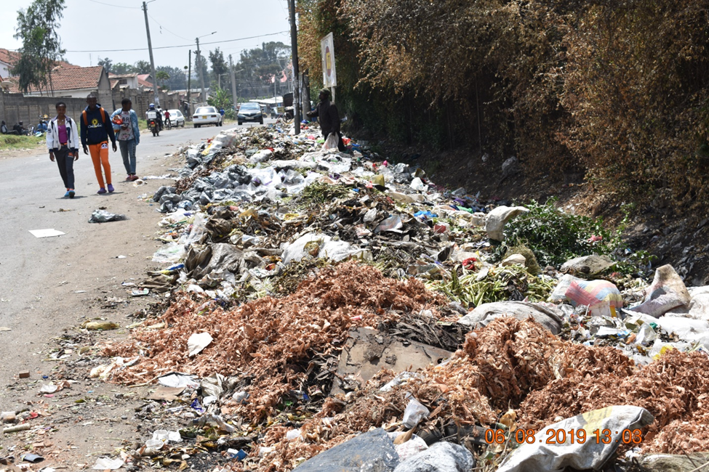
NECC Photo 8.8.2019
Figure 1: Waste dumped along the a road next to Railway Training Institute

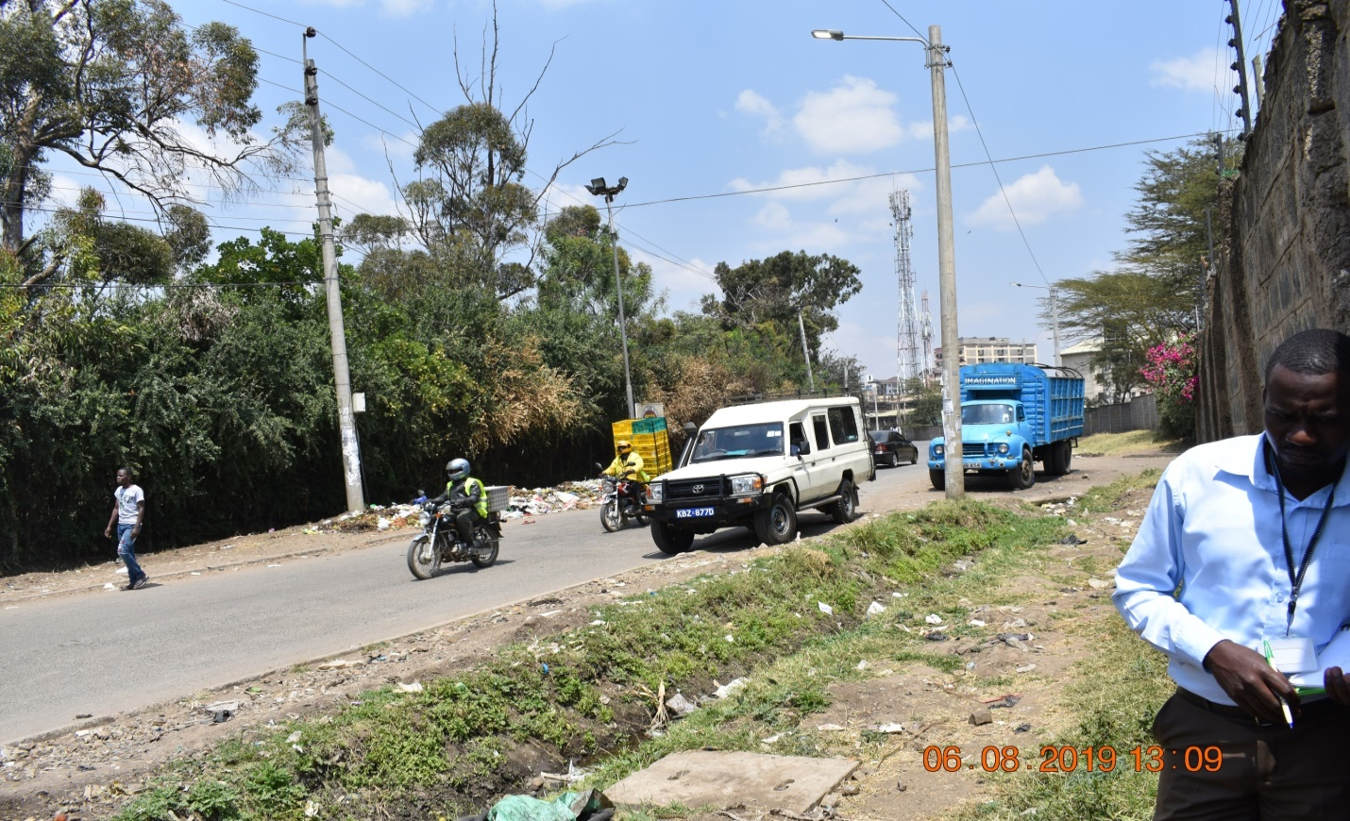
NECC Photo 2.08.2019
Figure 2: A truck with waste at the site

In Nakuru, it is estimated that 45% of the waste generated is collected and disposed at Giotto Dumpsite, 18% is recovered and the rest accumulate in the environmental.

Table 1: Status of solid waste generation, collection and recovery in major towns
Name of town | Estimated waste generated (Tons/day) | % waste collected | % waste recovery | Uncollected waste
Nairobi | 2400 | 80 | 45 | 20
Nakuru | 250 | 45 | 18 | 37
Kisumu | 400 | 20 | - | -
Thika | 140 | 60 | 30 | 40
Mombasa | 2200 | 65 | 40 | 35
Eldoret | 600 | 55 | 15 | 45
Source: National Solid waste management strategy-NEMA 2014

In Busia County, NECC observed that waste receptacles were at different areas within Busia Town which is the County’s headquarters. Waste generated from urban areas include organic waste from markets, plastic bottles and packaging materials among others. The receptacles were filled to capacity and some waste spilled over. Accumulation of waste has been exacerbated by infrequency in the collection of garbage. The County Government of Busia, just like in other Counties, was experiencing shortage of personnel and equipment for the management of solid waste.

In Kisii County, Public health department is responsible in cleaning of the CBD, collection, transportation of waste to Nyakoe Dumping site and management of the site. However, the department faces challenges in ensuring proper waste management due to insufficient resources and personnel. Additionally, Nyakoe dumpsite is not a designated site as per the NEMA regulations for siting a waste dumping site, it is open and unfenced, posing a risk to area residents, it is located next to a stream, and adjacent to the Kisii Level 5 hospital, as well as a residential building.
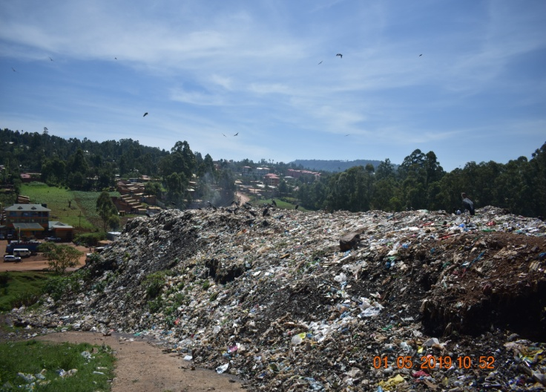
NECC Photo 1.05.2019
Figure 3: Open and unfenced dumping site in Nyakoe- Kisii Town

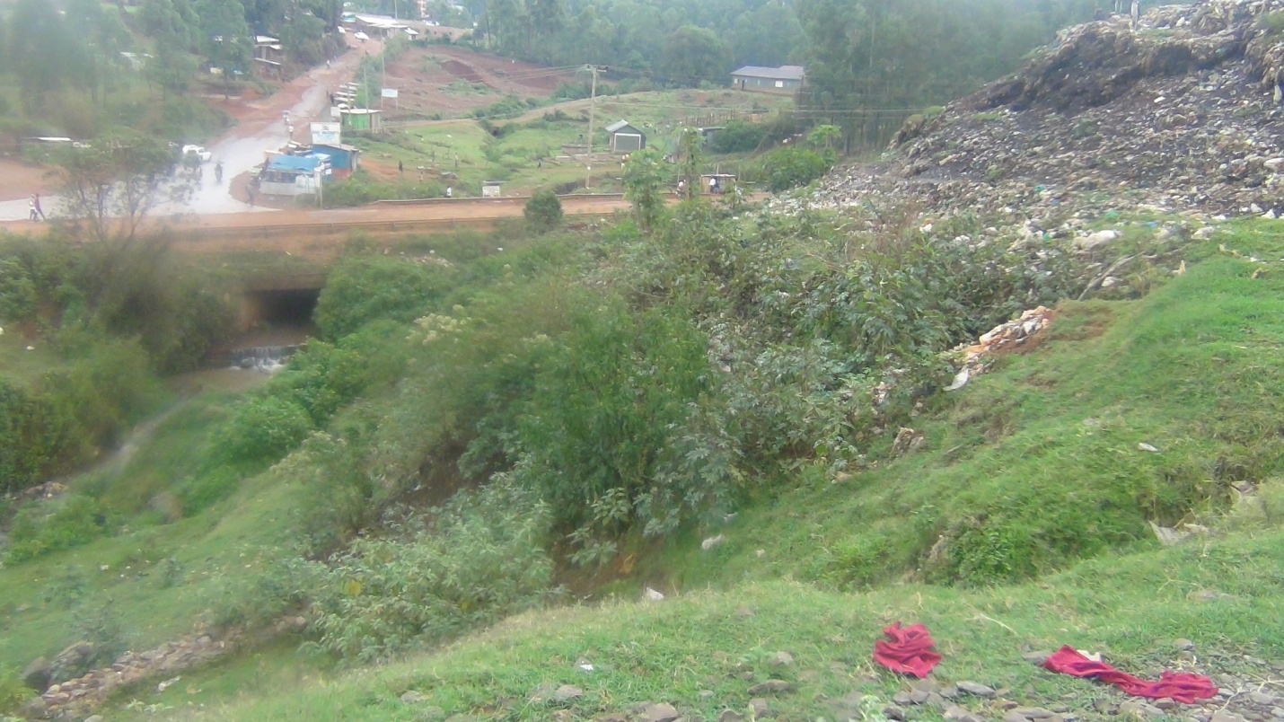
NECC Photo 1.05.2019
Figure 4: Nyakoe dumpsite located adjacent to a stream posing likelihood to affect environment and human health

Findings by NECC established that the County Government of Kisii was in the process of obtaining a designated site within the County that will be used to manage solid waste from Kisii Town and its environs. However, NECC reiterated the need for Public Consultation prior operation of the identified site.

A common observation made by NECC across most Counties is haphazard dumping of waste within towns/urban areas which is a health hazard to the public and has caused environmental pollution. NECC recommends that the County Governments ensure that waste is regularly collected and properly disposed so that the urban areas remain clean.

Waste transportation is largely rudimentary using open trucks, hand carts, donkey carts among others. These poor transportation modes have led to littering, making waste an eye-sore, particularly plastics in the environment. However, some counties have adopted appropriate transportation trucks as stipulated by the Waste Management Regulations. In addition, County Governments have privatized waste transportation through Private Public Partnership arrangements.

For efficient management of waste, there is need to weigh or estimate the amount of waste generated in tonnes to check whether the waste management facilities have the capacity to handle the Waste. However, this is not the case in most Counties as the waste is collected and disposed in the dump sites without being weighed. Additionally, there is no current data on generation, recovery and disposed waste. This challenges designing and implementing efficient measures that match the data in ensuring efficient waste management.

Disposal of waste in the country remains a major challenge as most of the counties lack proper and adequate disposal sites. The few towns that have designated sites practice open dumping of mixed waste as they lack appropriate technologies and disposal facilities. NEMA directs that all County Governments should designate areas of waste disposal and undertake basic actions to manage the sites including fencing, manning and weighing of the waste to ensure proper management of the dumping sites.

Disposal sites are undesignated this is due to the fact that they are either located in close proximity to residential areas, surface water sources, hospitals, schools and other vital facilities. The close proximity causes environmental pollution that increases chances for occurrence of human illnesses. Open disposal sites also face management challenges as communities around are against their location. Therefore, there is need for Counties to undertake research and identify suitable areas to cite waste management facilities.

There is minimal prioritization for waste management in the counties has led to inadequate budgetary allocation. As a result, management of the entire waste management cycle (collection, transportation and disposal) is hampered. Low funding has also affected investment in waste management facilities and equipment. Therefore, there is need for Counties to allocate sufficient funds to implement environmental issues
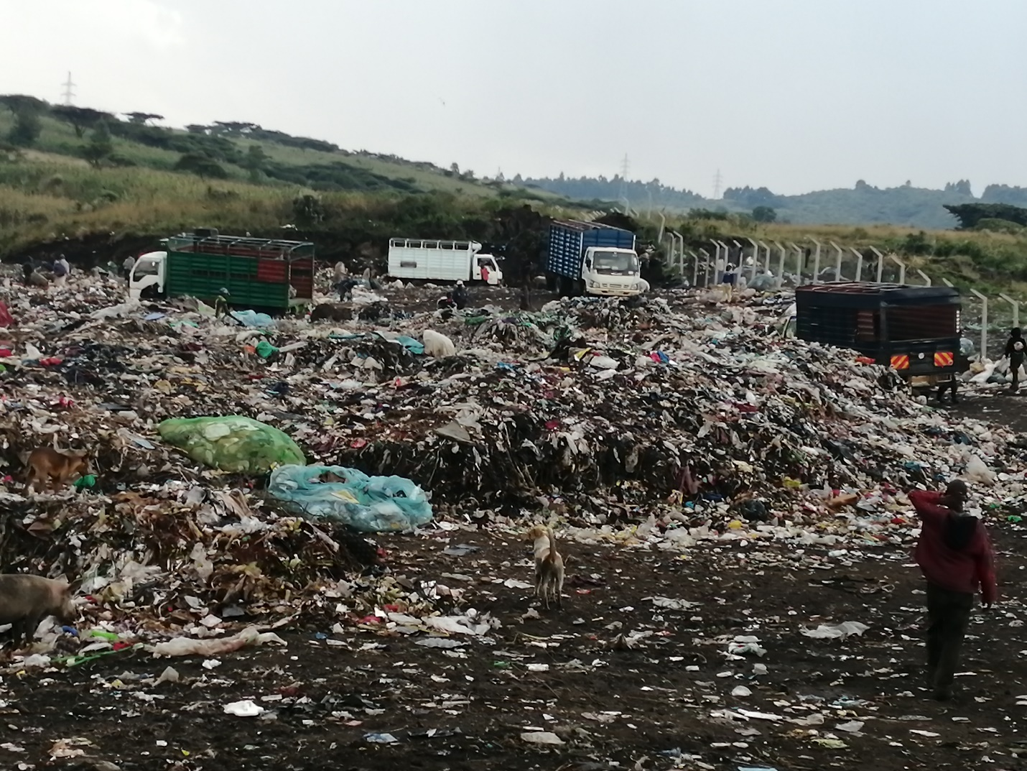
Figure 5:Gioto open solid waste dumping site in Nakuru County NECC Photo 3.11.2020

Solid Waste Management in Sugar Factories.

During the current reporting period, NECC investigated complaints on environmental degradation by sugar factories in Kenya. The factories had almost similar challenges in managing by-products from the sugar milling process which include bagasse, filter mud, leachate, vinasse and effluent. In most cases, the by-products ended up polluting the environment. The factories investigated include Kibos Sugar and Allied Industries Limited, Butali Sugar Mills Company Limited, Western Kenya Sugar Company Limited,

Transmara Sugar Company Limited and Kwale International Sugar Company Limited. During the manufacture of sugar, large volume of waste water (effluent) is generated. The effluent contains a huge quantity of pollution load, particularly in terms of suspended solids, organic matter, and mud. It also contains chemicals used in the industry mainly for coagulation of impurities and refining of end products. The process also produces bagasse and air pollutants like fly ash. Sugarcane bagasse refers to the fibrous matter that remains after crushing sugarcane for juice extraction. This residue can be used for either energy production or non-energy applications. For energy production, bagasse can be burned as raw product or in the form of briquettes.

Currently, bagasse is burned in boilers to produce steam which is utilized in factories and by power turbines for production of electricity. Sugar is a significant agricultural product and industries processing sugar are vital to the Kenyan economy. The sugar industry has made significant contribution to Kenya's agro-based economy in particular, and Kenyan economy in general. The sugar manufacturing industry is essential in the production of many varieties of foods. Sugar is used in cakes, ice cream, candy, and soft drinks as well as in other foods and beverages. In Kenya, most sugar mills are situated in the countryside and operate for up to eight months after harvesting of sugarcane.

A large volume of waste of organic nature is produced at the factories, which are normally discharged onto land or into nearby watercourses, usually small streams, practically without pre-treatment. Conditions become worse as the stream flow reaches a very low level and when enough dilution water is not available during the period of operation of the Sugar mills (early November to end of May or June). Putrefaction of the polluted stream water caused by the heavy discharge of organic waste, resulting in odour nuisance near sugar mills has been a very common phenomenon. When the untreated effluents are discharged into the environment, they disrupt the ecological area of living organisms. Effluent discharges from sugar mills constitute a number of chemical pollutants, such as oil and grease, carbonate, bicarbonate, nitrite, phosphate, in addition to total suspended solids.

Recommendations
- NEMA, WRA and the Public Health Office should ensure that the sugar companies stop discharging the untreated effluent and bagasse leachate into water ways as it poses serious health risks to area residents and users downstream.
- NEMA and WRA should ensure that the companies relocate the bagasse holding area which are on wetlands.
- NEMA and WRA should conduct regular analyses of all the water sources near the companies, bagasse holding sites and effluent from the treatment plant to ensure that they meet the water quality standards.
- NEMA and the Public Health Office should ensure that respondent cover bagasse to prevent it from being blown by wind to nearby homes and also to prevent water from seeping through to form leachate which is likely to cause groundwater contamination.
- WRA should demarcate riparian reserve of rivers near the sugar companies and place beacons to curb encroachment
- NEMA should ensure that all sugar companies put in place an effluent treatment plant with adequate capacity to handle all the effluent generated by the company's activities.
- NEMA should ensure that the companies strictly adhere to the conditions of the effluent discharge licenses issued.

Asbestos

During the 2018-2019 reporting period, NECC investigated complaints on environmental degradation due to poor handling of asbestos. A case in point that portrays a bigger picture of the problem in most hospitals in Kenya is the 35 year old Nyanza Provincial Hospital roofed with asbestos. The scenario is rather worrying for the material used on the hospital's roof keeps disintegrating, especially during rainy seasons. Sections of the roof have been patched with iron sheets after patches of asbestos fell off leaving spaces for leakage. It is not uncommon to find pieces of asbestos scattered in the hospital compound. During cleaning, workers collect the pieces in wheelbarrows and dump them at a dumpsite, where children from surrounding estates retrieve the materials to play with. The same scenario was going on in Machakos County until the asbestos was removed from the roof. In Nakuru County, poor disposal of Asbestos caused locals to obtain same material for reuse. Asbestos was reused to make- shift kiosks along the road as shown in Figure below.

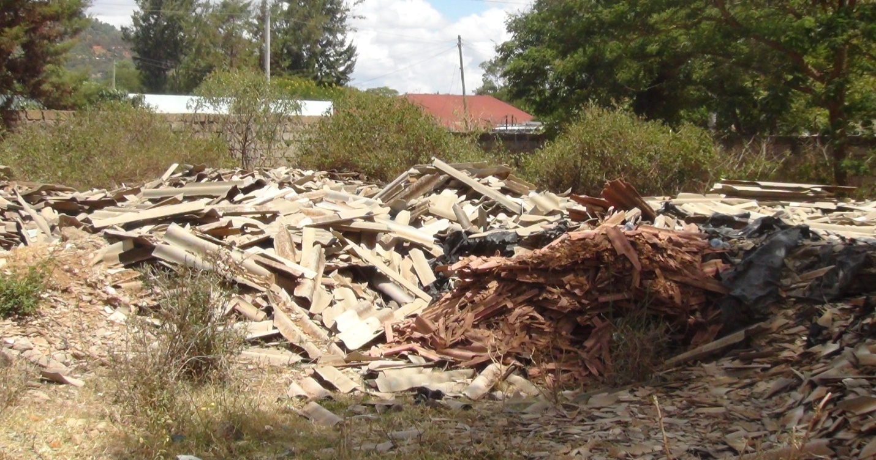
(NECC Photo 19.02.18)
Figure 6: Fig 1: Asbestos dumped in the open in Machakos County

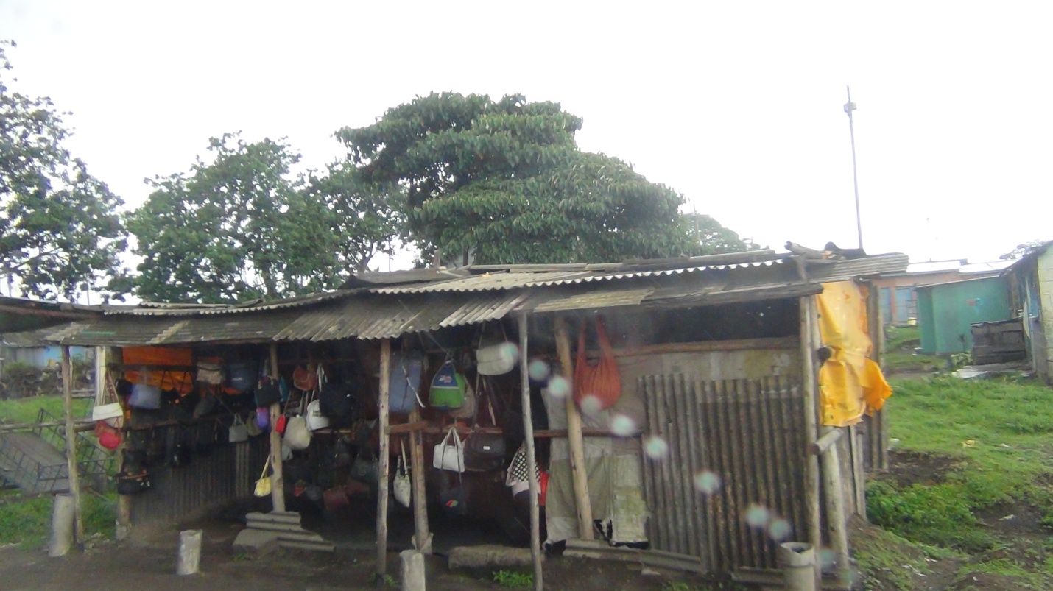
(NECC Photo 11/8/2017)
Figure 7: A kiosk by the roadside made of asbestos material

Recommendation
NECC recommends that the respective County Governments should acquire land that will be used for disposal of asbestos within the county. Additionally, NEMA in conjunction with County Government and Public Health Officers should undertake intensive sensitization of the public on the best ways of handling asbestos. As a safeguard, NEMA should impose deposit bonds on all high risk projects such as the disposal of asbestos to ensure disposal is done by the book. The Government should implement and enforce the various international instruments and MEA's on handling of asbestos through the existing laws and policies. This will ensure that the ban on asbestos is fully implemented with the aim of mitigating the negative health impacts associated with it.

CHALLENGES IN WASTE MANAGEMENT

Waste management in Kenya has remained a major challenge due to diverse factors. This range from problems associated with waste management systems, limited knowledge, attitude and practices, political will, technical and financial resources. Lack of awareness and knowledge: There is limited awareness and knowledge on the importance of a clean and healthy environment. This has led to poor practices by the Public towards waste management which has led to environmental pollution. As such there is poor handling of waste at the household level including lack of segregation, reuse, reduce and recycling. In addition, negative attitude towards waste management and failure to take individual responsibility has contributed to poor practices such as littering, illegal dumping and open burning.

Disposal sites: Availability, siting and management.

The county governments are expected to designate waste disposal sites/facilities within their areas of jurisdiction. However, the availability of public land for the purpose of a disposal site remains a challenge. In situations where the land is available, the neighboring communities are opposed to it being in their backyard. This is as a result of poor management of the existing sites. This has culminated in dumpsites being sited on environmentally sensitive areas such as river banks, forests and wetlands.

Funding:

Lack of prioritization for waste management in the counties has led to inadequate budgetary allocation. As a result management of the entire waste management cycle (collection, transportation and disposal) is hampered. Low funding has also affected investment in waste management facilities and equipment.

High poverty levels:

High poverty level especially in informal and low income settlements has compromised the ability to pay for waste management services. This has led to lack of collection leading to illegal waste dumping in undesignated areas sites, streams, rivers and highways. The situation is further compounded by lack of access and waste management infrastructure.

Lack of segregation

There is lack of waste segregation at source leading to mixed wastes which are collectively disposed off in the dumpsites. Where sorting is done, the problem is compounded by the lack of compartmentalized vehicles for transportation of the sorted waste leading to the remixing. This hampers material recovery, reuse, and recycling. The sorting has largely been relegated to the lowly in society such as the waste pickers and street urchins

Limited technical competencies:

As a Country, we are faced by limited technical competencies in waste management. This has led to poor management of our waste management facilities and equipment and their failure to attain optimal operating capacities.

Slow adoption of modern technological options:

Although there are many waste management technologies in the country, there has been low adoption of the same by the relevant practitioners. This as a result of diverse factors including inadequate financial resources to purchase the equipment, lack of incentives including tax waivers, resistance to change, lack awareness, unavailability of land and weak enforcement

FINDINGS ON CURRENT WASTE MANAGEMENT PRACTICES AND RECCOMMENDATIONS

The following are the prevailing waste management practices across most Counties

Waste Segregation

- Most of the waste is generated at household, market places, cities, towns, institutions and industrial zones
- Very few households segregate waste at the household level
- There is minimal waste segregation at source within the CBD areas, industries, institutions in most towns/cities
- There is considerable segregation of biomedical waste
- Recovery of recyclable items like plastics, papers, glass and metals is done by a increasing number of informal groups

Collection and Transportation

- Waste in the CBDs is largely collected by the County Governments while private operators dominate collection in residential areas at a fee
- Waste collection in low income and informal settlements is mainly done by organized groups and CBOs
- Waste collectors obtain permits from the County Governments to collect waste from designated areas

Waste Disposal

Most of the municipal and domestic waste generated is disposed of in open dumpsites across the country. Although this is not a recommended practice it is the most common practice

- Biomedical waste is largely disposed through incineration and rudimentary kilns;
- Condemned, damaged or expired goods are disposed through incineration or in the cement kilns
- The existing incineration facilities have been largely burners and kilns and do not meet the requirements stipulated the Third schedule of the waste management regulations of 2006
- Most of workforce operating these disposal sites have minimal or no training on how to manage these facilities.

RECOMMENDATIONS

- The National Government should ensure that the National Waste Management Strategy is fully implemented in all counties for effective waste management in Kenya.
- Additionally, the Government through the concerned agencies should wholly enforce the legal frameworks on waste management.
- The County Governments should ensure that waste is frequently collected at collection points so that waste does not accumulate and is not an irritant to the public.
- As a long term solution, County governments should venture into recycling as a way of managing the generated waste

REFERENCES
- A biodiversity Atlas: Kenya's Natural Capital. (2015)
- Brundtland GH, & World Commission on Environment and Development. (1987) Our Common future: report of the world commission on environment and development.
- Fileadmin/fm-wwf/Publikationen-PDF/Living_Forests_Chapter_1.pdf)
- Government of Kenya, (2007), Kenya Vision 2030,Nairobi;Government press
- Government of Kenya. (2010). Constitution of Kenya. Nairobi: Government Press
- Http://www.afforum.org/sites/default/files/English/English_159.pdf )
- Http://www.environmentalpollution.in/waste-management/sugar-industry-process description-and-wastewater-treatment/2846
- tps://hapakenya.com/2017/05/31/kenyas-garbage-problem-can-be-tackled-byproper-waste-management/)

